DOCKER DESKTOP MIGRATION TO WSL 2 ON WINDOWS

## By Andrea Vargas

Content

**Validate Virtualization on Task Manager** **3**

**Turn on Windows features virtualization** **4**

**Open Powershell as Administrator and run the following commands** **5**

**If it fails then follow the steps bellow:** **6**

**Open WSL window to do package repository configuration** **8**

**Update your Ubuntu distribution** **8**

**Remove Residue from previous docker installations** **8**

**Install official Docker release** **8**

**Add user to docker group** **9**

**Install docker on Windows** **9**

**IF YOU ARE USING VPN CONNECTION** **9**

**Get address from WSL(Ubuntu) environment** **9**

**Open Power shell as Administrator and execute the following command and replace the IP at the end** **9**

**Init docker** **10**

**If it fails Open again wsl ubuntu window and run:** **10**

**Set Docker System environment variable on Windows** **10**

**Test docker command from windows command line** **10**

**If you lose the connection inside the Ubuntu environment run this commands from the Windows command line** **11**

**Get address from WSL(Ubuntu) environment, this IP changes when you restart your laptop** **12**

**Open Power shell as Administrator and execute the following command and replace the IP at the end** **12**

**Init docker** **12**

**References** **13**

# 

# Validate Virtualization on Task Manager

* Performance
* CPU

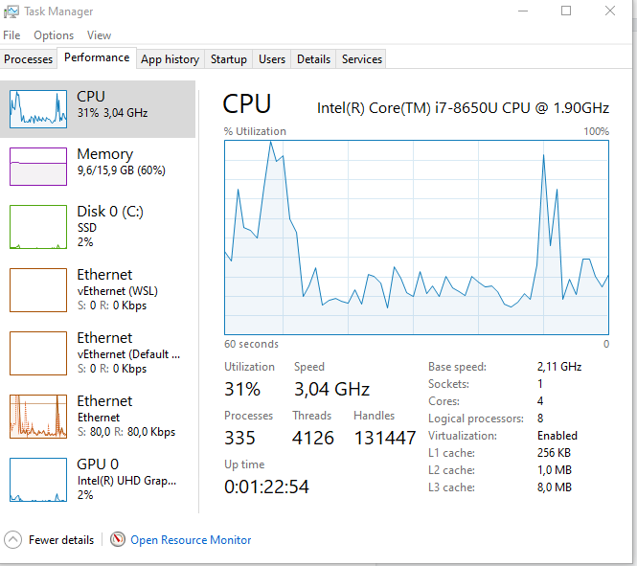

If virtualization is disable you can check this video

[How to enable virtualization in Bios windows 10](https://www.youtube.com/watch?v=Ub3I14BwODU)

# Turn on Windows features virtualization

# 

* Go turn Windows features or Off

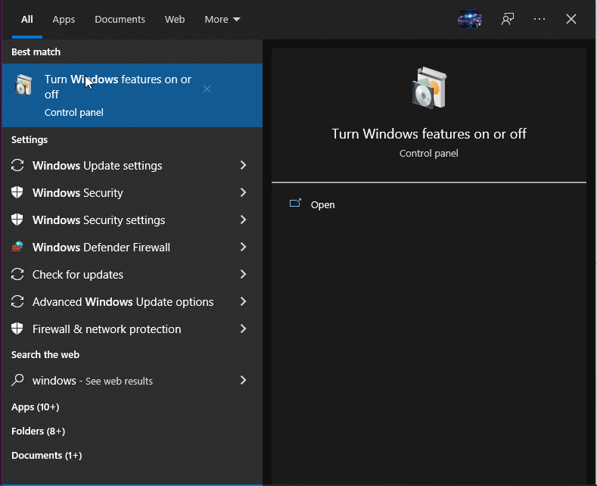

Active features: Hyper-V and Windows subsystem for Linux

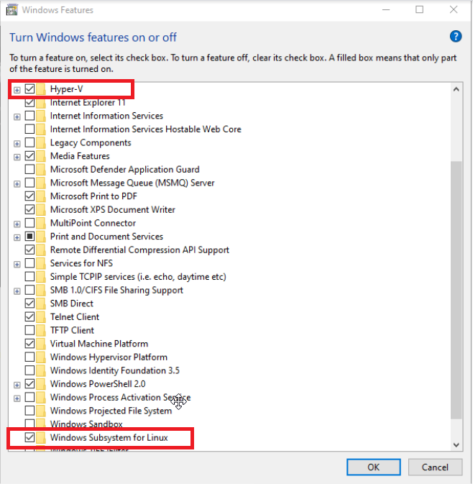

Restart your laptop

# Open Powershell as Administrator and run the following commands

To check wsl distributions

| wsl -l -v |
| --- |

To set the default wsl 2

| wsl --set-default-version 2 |
| --- |

To Install ubuntu

| wsl --install -d Ubuntu |
| --- |

Set default WSL distribution

| wsl --set-default $DISTRIBUTION-NAME (Ubuntu) |
| --- |

Set username and password

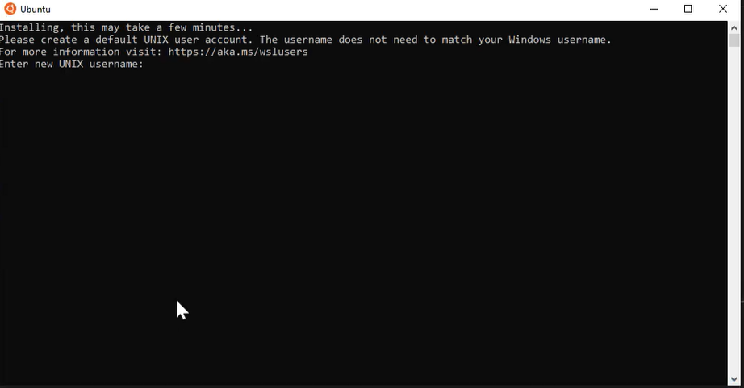

| ping google.com |
| --- |

# If it fails then follow the steps bellow:

* Download the distro [wsl-vpnkit.tar.gz](https://github.com/sakai135/wsl-vpnkit/releases) and copy it to C:\Users\<username>
* Open a PowerShell in **C:\Users\<username>** and run these commands

| wsl.exe --import wsl-vpnkit $env:USERPROFILE\wsl-vpnkit wsl-vpnkit.tar.gz |
| --- |

| wsl.exe -d wsl-vpnkit |
| --- |

| wsl.exe -d wsl-vpnkit service wsl-vpnkit start |
| --- |

* To prevent having to re-run any commands, open a WSL 2 session window and run

| sudo nano ~/.bashrc |
| --- |

Append this command at the end of the file and save

| wsl.exe -d wsl-vpnkit service wsl-vpnkit start >/dev/null 2>&1 |
| --- |

To save the file :

Ctrl + X

Y

Enter

.bashrc runs on every interactive shell launch.

* Close and re-open a new WSL 2 session. To confirm network access, run a ping command

| ping google.com |
| --- |

### 

# Open WSL window to do package repository configuration

| source /etc/os-release |
| --- |

| curl -fsSL https://download.docker.com/linux/ubuntu/gpg | sudo apt-key add - |
| --- |

| echo "deb [arch=amd64] https://download.docker.com/linux/ubuntu ${VERSION_CODENAME} stable" | sudo tee /etc/apt/sources.list.d/docker.list |
| --- |

# Update your Ubuntu distribution

| sudo apt update && sudo apt upgrade |
| --- |

# Remove Residue from previous docker installations

| sudo apt remove docker docker-engine docker.io containerd runc |
| --- |

# Install official Docker release

| sudo apt install docker-ce docker-ce-cli containerd.io |
| --- |

# Add user to docker group

Replace the $USER with your user

| sudo usermod -aG docker $USER |
| --- |

# Install docker on Windows

[GitHub](https://github.com/StefanScherer/docker-cli-builder/releases) download the docker.exe command in standalone :

* Download the exe
* Put it in the directory like c:\bin, create the folder if does not exist
* Add this directory in the path for executables : *System Properties\Environment Variables\System Variables\Path*

# IF YOU ARE USING VPN CONNECTION

# Get address from WSL(Ubuntu) environment

**Use the command:**

| ip addr | grep eth0 |
| --- |



# Open Power shell as Administrator and execute the following command and replace the IP at the end

| netsh interface portproxy add v4tov4 listenport=2375 listenaddress=0.0.0.0 connectport=2375 connectaddress=172.22.32.26 |
| --- |

# Init docker

| wsl sh -c "sudo dockerd -H tcp://0.0.0.0" |
| --- |

# If it fails Open again wsl ubuntu window and run:

| rm -rf /var/run/docker.pid |
| --- |

Or kill the PID

| lsof |
| --- |

Search the PID

| Sudo kill $pid |
| --- |

# Set Docker System environment variable on Windows

| *DOCKER_HOST value tcp://localhost:2375* |
| --- |

## 

# Test docker command from windows command line

| docker run -it hello-world |
| --- |

You will see something like 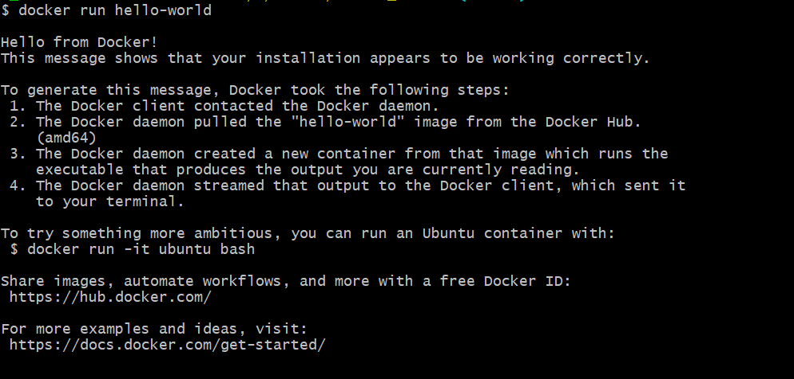

# If you lose the connection inside the Ubuntu environment run this commands from the Windows command line

| wsl -l -v wsl.exe -d wsl-vpnkit service wsl-vpnkit start |
| --- |

Daily process to work with Docker

# Get address from WSL(Ubuntu) environment, this IP changes when you restart your laptop

**Use the command:**

| ip addr | grep eth0 |
| --- |



# 

# Open Power shell as Administrator and execute the following command and replace the IP at the end

| netsh interface portproxy add v4tov4 listenport=2375 listenaddress=0.0.0.0 connectport=2375 connectaddress=172.22.32.26 |
| --- |

# Init docker

| wsl sh -c "sudo dockerd -H tcp://0.0.0.0" |
| --- |

Workaround docker-compose

* Add environment variables and commands on dockerfile
* Build image from dockerfile with the command

| docker build -t $imageName $DockerfileLocation |
| --- |

* Run the container with the command

| docker run -dp 8080:8080 $imageName |
| --- |

# References

* <https://dev.to/_nicolas_louis_/how-to-run-docker-on-windows-without-docker-desktop-hik>
* <https://www.youtube.com/watch?v=yCK3easuYm4&t=664s>
* <https://www.youtube.com/watch?v=NpN8CraDr0A>

Coming soon video about this on my youtube channel

[Coding Together ENG - YouTube](https://www.youtube.com/channel/UCJ79Hao8TFBFc2HuWPSuqOg)